

**Software Requirements Specification**

**for**

**HAPPY US!**

**Version 1.0 approved**

**Prepared by**

**Diya Agrawal, Harshak Chaudhari,**

**Parth Deshmukh, Ayush Chakote**

**Vishwakarma Institute of Information Technology, Pune**

**18-2-2023**

**Table of Contents**

1. Introduction

1.1 Purpose

1.2 Intended Audience

1.3 Scope

1.4 Definitions

1.5 References

2. Overall Description

2.1 Product Perspective

2.2 Product Functions

2.3 User Interface

2.4 System Interface

2.5 Assumptions and Dependencies

2.6 Operating Environment

2.7 User Classes and Characteristics

3. System Feature Requirements

3.1 Functional Requirements

3.2 Use Cases

3.3 External Interface Requirement

3.4 Non Functional Requirement

1. **Introduction**
   1. **Purpose**

Happy us is a web application for people who are having mental stress and anxiety issues, Happy us will be the solution to this problem. The aim of the project is to connect people who are having the same issues. They can take help from the therapist, attend musical therapy, motivational speaker sessions, and much

more.

* 1. **Intended Audience**

Our Intended Audience is mainly those users having mental stress and they aren’t able to cope with it. We are making them an available lot of things that can help them on a single platform.

1. People experiencing stress related to work, school, relationships, or other life circumstances.
2. Individuals with anxiety disorders, such as generalized anxiety disorder, social anxiety disorder, or panic disorder.
   1. **Scope**

The software system being developed is a web application i.e **HAPPY US.** It is being developed for a user who is having mental stress and anxiety. And they want to cope with it. The system will be run on a central server with each user having a remote user interface through a web browser to interact with it. Happy us will allow any user to create an account to become a user. The system will allow users to post on a feed, make friends, daily habit tracker, and do morning exercise tips, and can attend various events.

1. Self-help tools: The web application can offer self-help tools such as guided meditations, breathing exercises, and relaxation techniques. These tools can be accessed anytime, anywhere, making it easy for users to manage their stress levels.
2. One-on-one counselling: The web application can provide users with access to licensed therapists or counsellors through one-on-one counselling sessions. This can help users receive personalized treatment and support.
3. Habit tracking: The web application can allow users to track their progress over time, helping them see how far they've come and encouraging them to continue their treatment.
   1. **Definitions**

Event: The user can attend various sessions.

Habit Tracker: The user can track the habit here.

Meaningful Life: Quotes page

* 1. **References**

<https://www.headtohealth.gov.au/>

1. **Overall Description**
   1. **Product Perspective**

A web application for the treatment of mentally stressed people should aim to provide an accessible and user-friendly platform that enables users to manage their mental health effectively.

* 1. **Product Functions**
     1. Guided meditations: The app may include a library of guided meditations that are specifically designed to help users manage stress.
     2. Breathing exercises: The app may include breathing exercises that can help users relax and reduce stress.
     3. Relaxation techniques: The app may include relaxation techniques, such as progressive muscle relaxation, that can help users physically and mentally relax.
     4. Mindfulness exercises: The app may include mindfulness exercises that can help users become more aware of their thoughts and feelings, and develop a more positive and accepting attitude towards them.
     5. Habit Tracking: The app may allow users to set goals related to managing their stress, and track their progress over time.
     6. Social support: The app may include social support features, such as a community forum where users can connect with others who are also managing stress.
     7. Educational resources: The app may provide educational resources, such as articles or videos, that can help users learn more about stress and how to manage it.
     8. Personalization: The app may allow users to customize their experience based on their preferences and needs, such as selecting the length or content of meditations, or setting reminders for breathing exercises.
     9. Support and feedback: The app may include resources for support and feedback, such as links to additional resources or access to trained mental health professionals.
  2. **User Interface**

Link : <https://www.figma.com/file/9qUqm7HDnaGChNjgmYCeul/Project---II?node-id=0%3A1&t=mrUIaQSWGz3VatPf-0>

**2.4System Interface**

Considerations for the system interface of a web app aiming to treat mentally stressed people:

* + 1. Simple and intuitive design: The interface should be designed to be easy to use, with clear and intuitive navigation that allows users to quickly find the features they need. A simple and clean design can help reduce cognitive overload and make it easier for users to focus on managing their stress.
    2. User-friendly language: The language used in the interface should be user-friendly, easy to understand, and non-judgmental. This can help users feel more comfortable and supported while using the app.
    3. Clear labelling: All features and functions should be clearly labelled so that users can quickly identify what they are looking for. This can help users navigate the app more easily and find the tools they need to manage their stress.
    4. Visual aids: The use of visual aids, such as icons or images, can help users quickly identify different features and functions, and make the app more visually appealing.
    5. Customization options: The app should provide customization options that allow users to personalize their experience based on their needs and preferences. For example, users may want to select different background colours or fonts, or adjust the volume of audio content.
    6. Accessibility features: The app should be designed to be accessible to users with a range of abilities. This may include features such as text-to-speech functionality, adjustable font sizes, or compatibility with screen readers.
    7. Feedback mechanisms: The app should provide clear feedback mechanisms, such as confirmation messages or progress indicators, to help users understand their actions and track their progress.
    8. Responsive design: The app should be designed to be responsive to different screen sizes and devices, so that users can access the app from anywhere on any device.
    9. Security and privacy: The interface should prioritize user security and privacy by implementing strong authentication measures, using secure data storage, and being transparent about how user data is used and protected.
    10. Support resources: The app should provide clear guidance and support resources, such as FAQs, tutorials, or links to additional resources. This can help users feel more comfortable and confident while using the app, and provide additional support for managing their stress.
  1. **Assumptions and Dependencies**

**Assumptions:**

1. Users have access to a reliable internet connection and a device with a web browser to access the web app.
2. Users are willing to engage with the web app and utilize the tools and resources provided to manage their stress.
3. Users have a basic understanding of web-based technology and are comfortable using digital tools.
4. Users are aware of their own mental health needs and are seeking out resources to manage their stress.
5. The app is not a substitute for professional medical advice or treatment and users are aware of this.

**Dependencies:**

1. The web app may depend on third-party libraries or software for some of its features and functionality, such as audio playback or database management.
2. The app may require regular updates and maintenance to ensure optimal performance and user experience.
3. The app may require ongoing support from developers or technical staff to address bugs or issues that arise.
4. The app may depend on the availability of trained mental health professionals to provide support and resources to users.
5. The app may need to comply with legal and ethical guidelines related to user privacy and data protection, which may require ongoing monitoring and compliance efforts.
   1. **Operating Environment**
6. Web server: The app will need a web server to host the application and store data. The web server should be reliable, secure, and scalable to handle increased traffic and usage.
7. Client devices: Users will access the web app from their client devices, such as smartphones, tablets, or computers. The app should be designed to be responsive to different screen sizes and devices, so that users can access the app from anywhere on any device.
8. Web browsers: Users will access the web app using web browsers such as Google Chrome, Firefox, or Safari. The app should be compatible with different web browsers and versions to ensure maximum accessibility for users.
9. Databases: The app will need a database to store user data such as stress assessments, progress tracking, and preferences. The database should be secure, scalable, and reliable to ensure data is protected and accessible.
   1. **User Classes and Characteristics**

**User Classes**

1. Individuals with mild to moderate stress: These users may experience occasional stress due to daily life events such as work, school, or personal relationships. They may benefit from tools and resources to manage their stress and prevent it from escalating into more severe mental health issues.
2. Individuals with chronic stress: These users may experience ongoing stress due to long-term factors such as work or family responsibilities, financial strain, or chronic health issues. They may benefit from more comprehensive tools and resources to manage their stress and improve their mental wellbeing.
3. Individuals with anxiety or depression: These users may have been diagnosed with anxiety or depression and may be seeking additional support and resources to manage their symptoms. They may benefit from tools and resources that are tailored to their specific mental health needs.
4. Caregivers or family members: These users may be providing support for a loved one who is experiencing stress or mental health issues. They may benefit from resources and information to help them better understand the condition and provide effective support.
5. Mental health professionals: These users may include licensed mental health professionals such as therapists, counsellors, or psychiatrists who are using the app to provide additional support and resources for their patients.

**Characteristics**

1. Awareness of their own mental health needs and a desire to manage their stress.
2. Willingness to engage with digital tools and resources to improve their mental wellbeing.
3. Access to technology such as smartphones or computers with an internet connection.
4. A basic understanding of web-based technology and ability to navigate web applications.
5. A willingness to share some personal information such as stress levels or personal preferences in order to receive personalized recommendations and support.
6. A commitment to using the app regularly over time to see lasting improvements in their mental health.

**3. System Feature Requirements**

**3.1 Functional Requirements**

1. User registration and profile creation: Users should be able to create an account, provide basic information about themselves, and create a personalized profile that can be used to track their progress and receive tailored recommendations.
2. Stress assessment and tracking: The app should provide a stress assessment tool that helps users identify their stress levels and track changes over time. This feature may include self-reported stress levels, stress triggers, and coping mechanisms.
3. Educational resources: The app should provide educational resources such as articles, videos, and podcasts that offer tips and strategies for managing stress and improving mental health.
4. Meditation and relaxation exercises: The app should provide guided meditation and relaxation exercises to help users reduce stress and improve their mental wellbeing.
5. Goal setting and progress tracking: The app should allow users to set goals related to their stress management and track their progress over time. This feature may include reminders and notifications to help users stay on track.
6. Personalized recommendations: The app should use data from the user's profile and stress assessment to provide personalized recommendations for stress management tools and resources.
7. Community support: The app may include a feature for users to connect with others who are experiencing similar stress and mental health issues. This feature may include chat rooms, discussion boards, and support groups.
8. Integration with other apps or devices: The app may integrate with other apps or devices, such as fitness trackers or meditation apps, to provide a more comprehensive approach to stress management and mental health.
9. Secure data storage: The app should use secure data storage and protect user data in compliance with legal and ethical guidelines related to user privacy and data protection.
10. Feedback and evaluation: The app should allow users to provide feedback on the app's features and functionality, and use this feedback to make improvements and updates over time.

**3.2 Use Cases**

1. Personal stress management: A user may use the app to track their stress levels, set goals for stress management, and receive personalized recommendations for tools and resources to improve their mental wellbeing.
2. Professional stress management: A user may be seeking additional support to manage stress related to work or other professional responsibilities. The app may provide resources such as time management tools, communication strategies, and other tools to reduce workplace stress.
3. Coping with a life change: A user may be experiencing stress related to a major life change such as a move, job loss, or a breakup. The app may provide tools and resources to help users manage their stress and adjust to the change.
4. Anxiety management: A user may have been diagnosed with an anxiety disorder and may use the app to track their symptoms, receive personalized recommendations for coping mechanisms and relaxation techniques, and connect with others who are experiencing similar mental health issues.
5. Depression management: A user may have been diagnosed with depression and may use the app to track their mood, set goals for improving their mental health, and receive personalized recommendations for tools and resources to manage their symptoms.
6. Caregiver support: A caregiver or family member may use the app to receive resources and support for providing care for a loved one who is experiencing stress or mental health issues.
7. Mental health professional support: A licensed mental health professional may use the app to provide additional support and resources for their patients, track their progress, and make personalized recommendations for stress management tools and resources.

**3.3 External Interface Requirement**

1. Web browsers: The app should be compatible with commonly used web browsers such as Google Chrome, Mozilla Firefox, and Apple Safari.
2. Mobile devices: The app should be responsive and accessible on mobile devices such as smartphones and tablets.
3. Social media platforms: The app may integrate with social media platforms such as Facebook, Twitter, and LinkedIn to allow users to share their progress and connect with others who are using the app.
4. Third-party apps and devices: The app may integrate with third-party apps and devices such as fitness trackers or meditation apps to provide a more comprehensive approach to stress management and mental health.
5. Payment gateways: The app will need a Payment gateway to book the tickets for an event.
6. APIs: The app may use APIs to access external data sources such as weather forecasts, news feeds, or location-based services to provide personalized recommendations for stress management tools and resources.
7. Security and privacy: The app should comply with legal and ethical guidelines related to user privacy and data protection. It should use secure data storage and encryption, and implement appropriate security measures to protect user data and prevent unauthorized access or data breaches.
8. Customer support: The app should provide channels for customer support such as email, chat, or phone to address user queries and technical issues.

**3.4 Non-Functional Requirement**

1. Usability: The app should be user-friendly and intuitive, with clear instructions and easy navigation. It should be designed to accommodate users with different levels of technical expertise and be accessible to users with disabilities.
2. Performance: The app should be responsive and load quickly to prevent frustration and provide a seamless user experience. It should be designed to handle high traffic and usage spikes without crashing or slowing down.
3. Reliability: The app should be reliable and available to users at all times, with minimal downtime or maintenance disruptions. It should be designed to recover quickly from any issues or errors to minimize user impact.
4. Scalability: The app should be designed to accommodate growth and scalability, with the ability to handle increasing user demand and data storage requirements.
5. Security: The app should be designed to protect user data and prevent unauthorized access, with appropriate security measures such as encryption, secure login, and data backups. It should comply with relevant data protection regulations and standards.
6. Accessibility: The app should be accessible to users with disabilities, with features such as screen readers, color contrast, and keyboard navigation.
7. Compatibility: The app should be compatible with a range of devices, operating systems, and web browsers, with a responsive design that adapts to different screen sizes and resolutions.
8. Maintainability: The app should be designed to be easily maintained and updated, with modular code and clear documentation to facilitate troubleshooting and future enhancements.
9. Privacy: The app should respect user privacy and be transparent about how user data is collected, used, and shared. It should provide users with the ability to control their data and opt-out of any data collection or sharing practices.

Appendix A: Glossary

UC :- Use Case

HU: Happy Us

B: Analysis Models

Use Case Diagram:

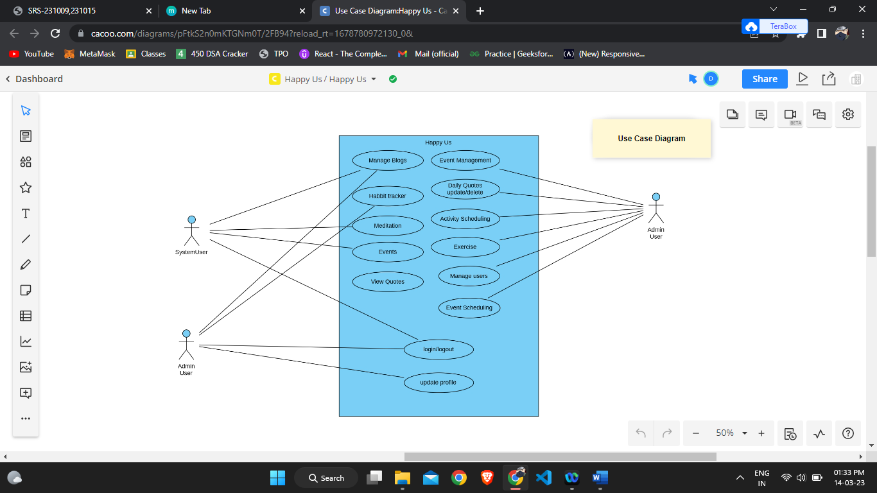

Class Diagram:

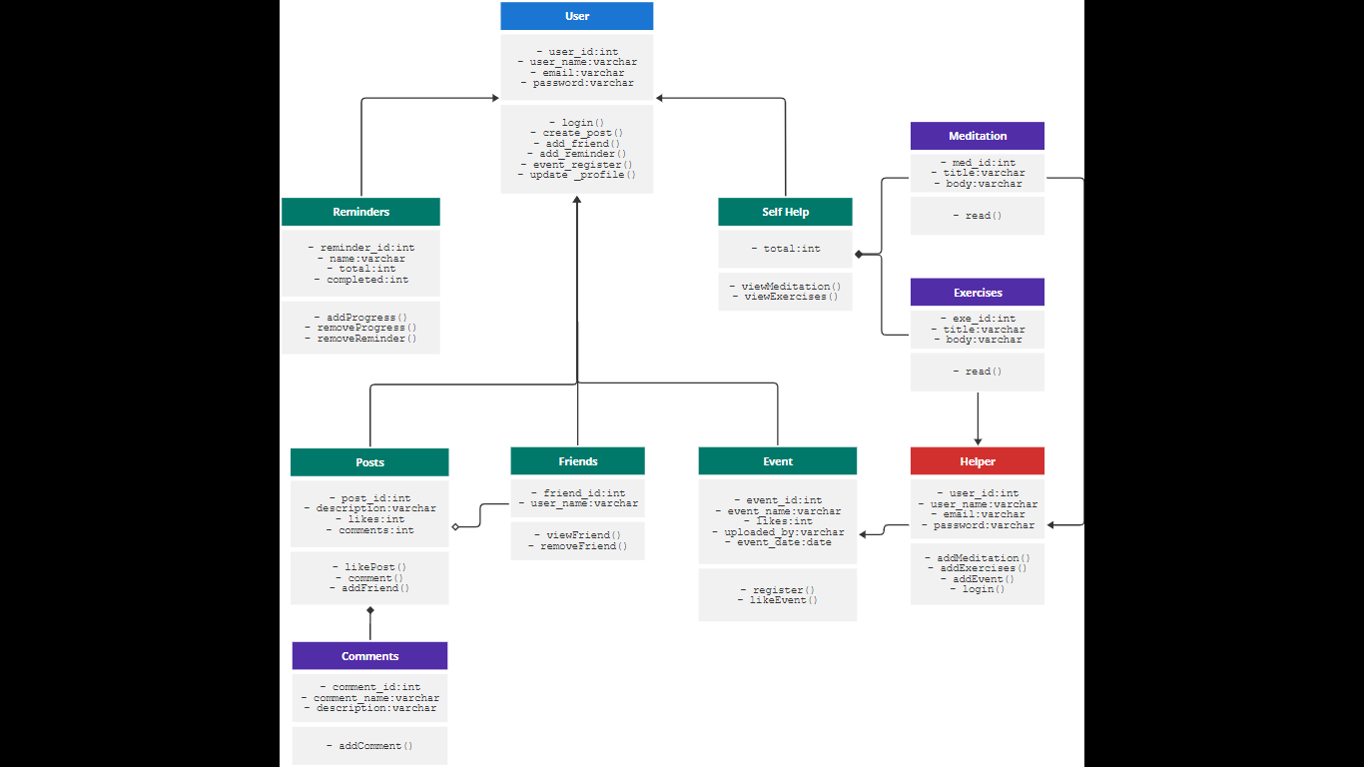

Activity Diagram:

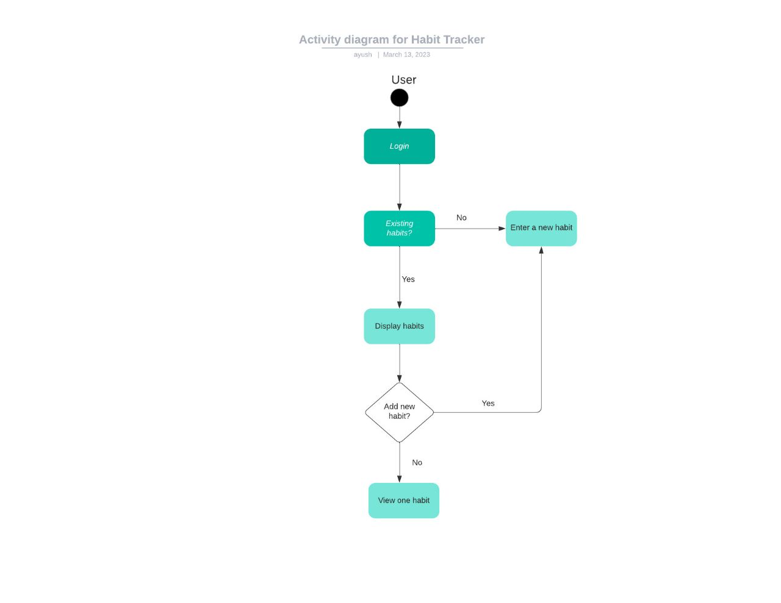

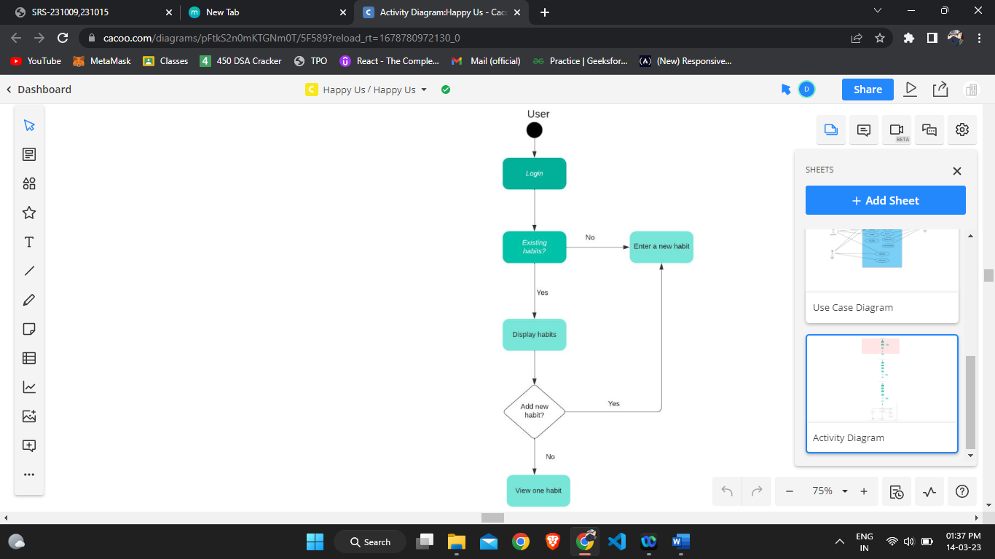

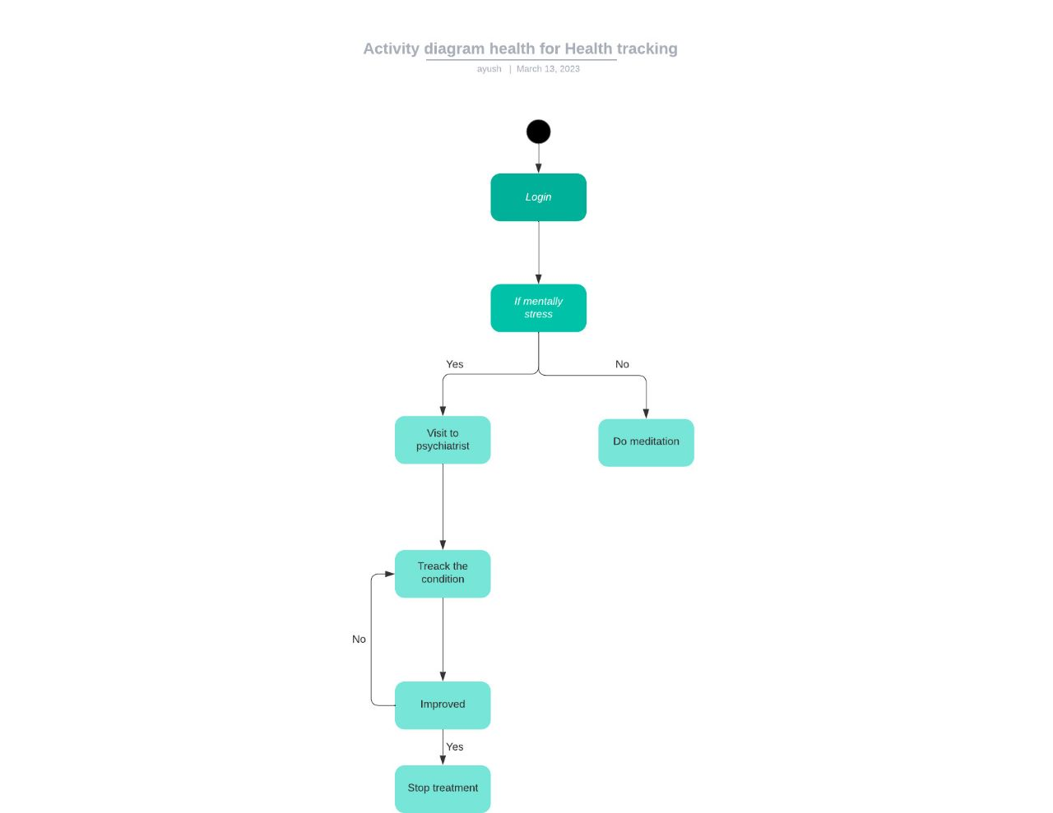

Sequence Diagram:

